XISP-Inc Alpha Cube Sat (ACS)
Rideshare Payload Questionnaire
Version 1-1 June 7, 2021

The following set of questions establishes baseline information that SpaceX will use to conduct analysis in support of program deliverables. Please answer the questions to the best of your knowledge for the currently payload configuration.

Payload Information
Mission Information
General Payload/Mission Description (including image):
Alpha Cube Sat (ACS), a 6U cubesat participating in NASA’s CubeQuest Challenge Deep Space Derby fielded by Xtraordinary Innovative Space Partnerships, Inc. (XISP-Inc). ACS is manifested on the Geometric-I Falcon 9 Rideshare mission scheduled for no earlier than June of 2022. In addition to competing in the CubeQuest challenge ACS is intended to incorporate multiple advanced communication and propulsion technology development payload elements, science payload elements, and one or more commercial elements depending on available volume.
Payload Type: SmallSat Side-Mounted 15” Port
(check all that apply)
CubeSat+Dispenser Forward-Mounted 24” Port

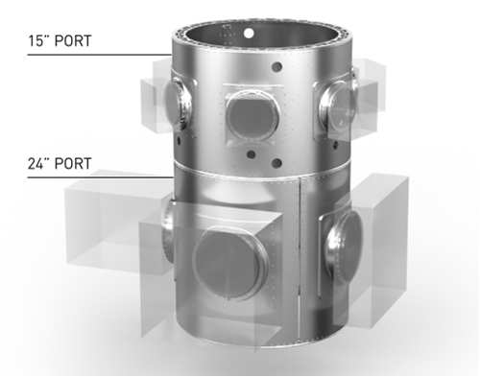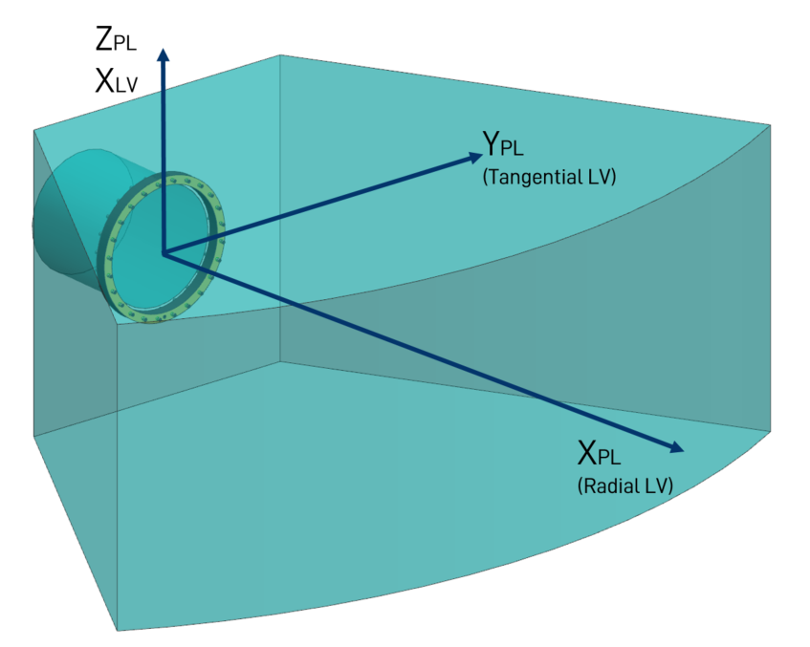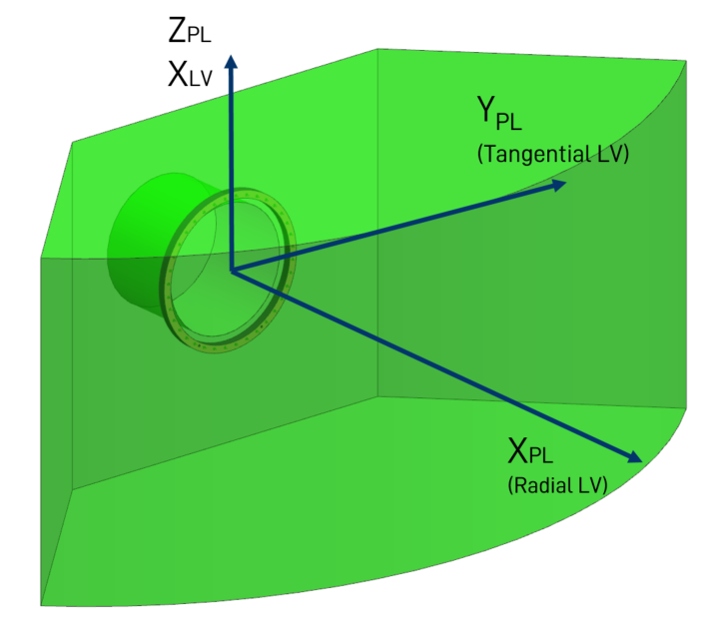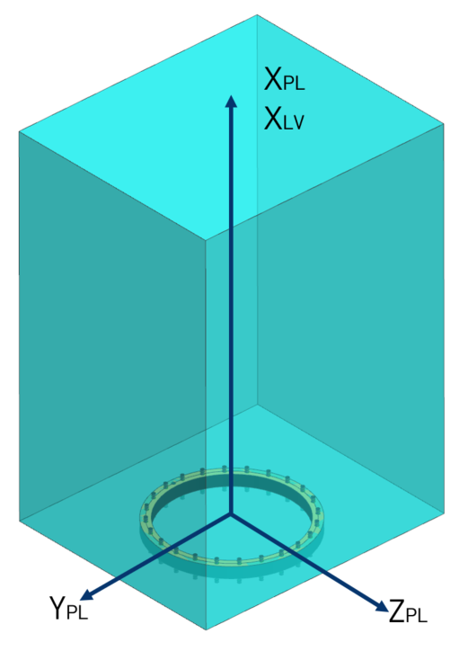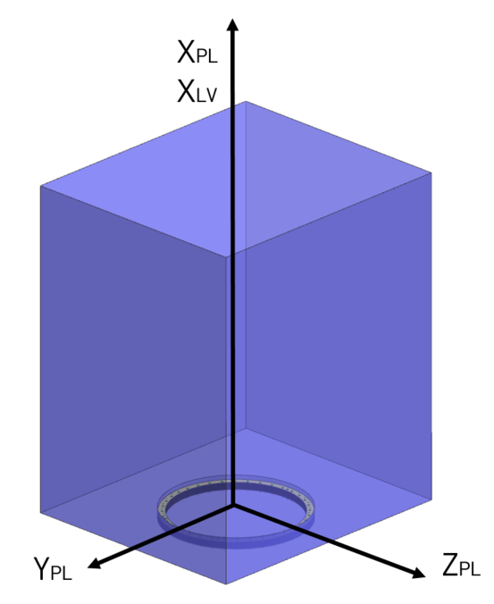
Forward-Mounted (Starlink)
Side-Mounted
15” Port
24” Port
24” Port
15” Port

Mission Design

Payload Separation Design Parameters
 |  | Value + Tolerance | SI Units
Target Separation Velocity |  | ± | m/s
Target Separation Tip off Rate | X_{SC} | ± | deg/s
 | Y_{SC} | ± | deg/s
 | Z_{SC} | ± | deg/s

Mechanical Interface
Payload Mass Properties
 |  |  | Value | SI Units
Maximum Payload Mass |  |  | 15 | kg
 |  | Stowed Configuration |  | Tolerance
Center of Gravity  (mm) | X_{PL} |  | TBD – Mercury 6 Payload Canister | ± TBD
 | Y_{PL} |  | TBD – Mercury 6 Payload Canister | ± TBD
 | Z_{PL} |  | TBD – Mercury 6 Payload Canister | ± TBD

Payload Mechanical Interface
 |  | Value | SI Units
Maximum Payload Length | X_{PL} | TBD – Mercury 6 Payload Canister | mm
 | Y_{PL} | TBD – Mercury 6 Payload Canister | mm
 | Z_{PL} | TBD – Mercury 6 Payload Canister | mm
Mechanical Interface: 24” 15” Other (please specify)

Payload Dynamics
 |  | Value | SI Units
Fundamental Frequency – PL Lateral |  | TBD – Mercury 6 Payload Canister | Hz
Fundamental Frequency – PL Axial |  | TBD – Mercury 6 Payload Canister | Hz
Payload Separation System
Type | Lightband Clampband CubeSat Dispenser Other*
Company | Maverick Space
Model | Mercury 6
Dimensions | TBD – Mercury 6 Payload Canister
* If Other (Please Explain)

Please provide a dimensional drawing and/or a CAD model of the Payload.

Electrical Interface
Payload Umbilical
Standard Rideshare channel allocations (and quantity) are defined below, please indicate if the Payload will require each:
Umbilical: Battery Charge (2) | No Yes
Umbilical: Battery Sense (2) | No Yes
Umbilical: Communication (2) | No Yes
Deployment (2) | Yes
Umbilical Breakwire (PL-side loopback) (1) | Yes

Launch Site Operations
Payload Batteries
How long do Payload batteries last in a flight-ready state before requiring a charge? | TBD
Will you be charging Payload batteries at the Launch Site? | Yes

Required Stand Alone Testing at Launch Site
 | Type | Duration | Safety Considerations
1 | Battery Okay | TBD | Battery would be in no-load heart beat mode
2
…

Propulsion System
Does the Payload have a propulsion system? Yes No
If “Yes”
 | Fuel Type | Estimated Volume | Fueling at Launch Site?
1 | H₂0 and/or H₂O₂ | TBD | Yes No
2 | Cold Gas | Optional -- TBD | Yes No
…

Additional Information:

- Please describe any safety issues associated with the Payload.
Spacecraft bus and payloads will be within already established and accepted risk parameters.

H₂0 and/or H₂O₂ -- H₂0 may be processed to H₂O₂ after deployment

- Please describe any security concerns or requirements for the Payload.
Spacecraft bus and payloads will be inert except for battery heartbeat until payload cannister deployment + established and accepted delay parameters.

- Please describe any additional Payload requirements for which SpaceX should be made aware (such as sensitivity to Helium).
Spacecraft (bus + payloads) may need to use a Delta-V as a service or other form of deployment optimization to minimize Delta-V required to reach alternate minimum energy trajectory insertion point. Calculations of Delta-V required are currently being recalculated based on the revised launch parameters and the available service options from Space-X and others. No sensitivity options have been identified to date.

