Team Alpha Cubesat
Mission Concept Registration Data Package
Final
April 30, 2015

Team Alpha CubeSat  c/o XISP-Inc  8012 MacArthur Boulevard  Cabin John, MD 20818-1608 |  |  |  | gary.barnhard@alphacubesat.com  +1 301 229 8012 http://www.alphacubesat.com

Table of Contents
- INTRODUCTION 2
Mission Statement
Team Members, Advisors & International Liaisons
Teammates & Sponsors
- CONCEPT OF OPERATIONS 4
Concept of Operations Narrative
Concept of Operations Diagram
- CONCEPTUAL MISSION DESIGN 9
Development Considerations
Ground Segment Considerations
Structural Considerations
Launch Considerations
Deployment Considerations
Trajectory Considerations
Attitude Control System Considerations
Communication Considerations
Articulated Subsystem Considerations
Electrical Considerations
Navigation Concepts
Propulsion Considerations
Command & Control Concepts
Thermal Considerations
Conceptual Considerations
Conceptual Method of Disposal
- PRELIMINARY FREQUENCY ALLOCATION DATA PACKAGE 23
EL-CID Status

INTRODUCTION
This document is intended to satisfy the NASA Cube Quest Challenge Mission Concept Registration Data Package (Operations and Rules, Rule 3) for Team Alpha CubeSat which is the initial product due Formal Registration Acceptance + 60 Days. The NASA confirmed due date for this submission by Team Alpha CubeSat is April 30, 2015.
Q3: Rule 3: Is there a rubric or list of expectations for the Mission Concept Registration Data Package that is due 60 days after registration? Are you expecting a series of trade studies, or a specifically formatted document with various sections?
A3: No, there is no specific format for the required content.
NOTE: Cube Quest anticipates adding some explanatory text to Rule 3 in the next edition of the Operations and Rules document.
That new text will be similar to this elaboration of Rule 3:
- The Mission Concept Registration Data Package can contain such information as: which Derbies (Lunar, Deep Space, or both) does the Team plan to compete in?
- Will the team compete for an EM-1 launch?
- What ground stations are planned for use?
- What propulsion technology?
- What communications subsystem?
- How will the CubeSat be controlled, navigate, achieve orbit, steer solar arrays or antennas or other directional mechanisms?
- What moving parts are there?
- Please include information that will give Judges insight into your Mission.

Mission Statement
The Alpha Cube Sat Team is out to win the NASA Cube Quest Challenge.
Our teams founding sponsor is Xtraordinary Innovative Space Partnerships, Inc. (XISP-Inc) http://www.xisp-inc.com
Our strategy is to succeed through a combination of competition and cooperation. We intend to leverage all available assets implementing the project as part of multiple profit driven technology development efforts underway by our teammates and sponsors.

Team Members, Advisors & International Liaisons
ALPHA CUBE SAT TEAM MEMBERS:
- Gary Barnhard – Team Leader
- Matteo K. Borri
- Michelle Kennedy Cadieux
- Ethan Shinen Chew
- Adam Glickman
- TJ McKinney
- Joseph Rauscher
- Jephrey Rodriguez
- John Tascione
ALPHA CUBESAT TEAM ADVISORS:
- Eric Dahlstrom
- Jerry Isdale
ALPHA CUBESAT TEAM INTERNATIONAL LIAISONS:
- Issac DeSouza
- Daniel Faber
- Joe Hatoum
- Joshua Skrzypek

Teammates & Sponsors
- Xtraordinary Innovative Space Partnerships, Inc. (Commercial)
- Barnhard Associates, LLC (Commercial)
- Deep Space Industries, LLC (Commercial)
- Space Development Foundation (Non-profit)

CONCEPT OF OPERATIONS
The Alpha CubeSat Concept of Operations is outlined below and shown in Diagram 1-1 Alpha CubeSat Concept of Operations. The driving factors have been a series of trades and opportunities resulting from innovative partnerships the team has been able to develop. Each of these are addressed in more detail in the Conceptual Mission Design section. The driving factors identified to date include:
- Integration & Launch Trade
  - SLS Secondary Cargo EM-1
  - Soft Pack Pressurized ISS Cargo
  - EVR Deployed Unpressurized ISS Cargo
- Deployment Trade
- ISS Low Earth Orbit to Deep Space and Cis-Lunar Trajectory Insertion
- Inert Automated Secondary Payload to Astronaut/Robotic Assembly and Release
- Deployment Kinetic Energy Transfer Trade
  - Mechanical Spring, zero preload until launch baselined using conservative interpretation of the rules.
  - Potential augments will be investigated to level playing field by accounting for energy imparted by the launch vehicle. Any use of such augments is subject to a favorable ruling by the Cube Quest Challenge Administration
  - Any constraints on the allowable space for deployment infrastructure that is beyond the nominal 6U envelope need to be defined.
- Leverage DSI/XISP-Inc Colab, Hardware and Software technical collaboration opportunities.
- Make use of alternate minimum energy trajectories (e.g., ISEE3 example, bi-elliptic, weak stability boundary, libration point, etc.)
- Mission Concept will be based on combined Deep Space and Lunar Derby missions
- The spacecraft will be a development testbed to gain operational experience/data points to raise technology readiness levels of various subsystem design elements.
- An ultra-lightweight 3-D printable primary structure using one or more of the allowable aluminum alloys is baselined, but alternatives will be considered.
- The use of unified bus backplane(s) is baselined.
- The use of integrated receiving antenna (rectenna) and solar arrays is baselined.
- The use of hybrid band gapped solar cells/solar concentrators is baselined.
- The use of a short duration high thrust propulsion system is baselined. An in-line hybrid Nitrous Oxide and Acrylic/Paraffin propulsion system is the leading alternative at this time.
- The use of a long duration and/or repetitive use low thrust propulsion system is baselined. Some combination of ion thrusters, solar sail, and cold gas thrusters will be incorporated into the Alpha CubeSat design and will be scaled to meet the mission requirements.
- The structural layout is assumed to be a 3 U center stack with Tandem 1.5U x 3U volumes on either side.

Concept of Operations Narrative
The concept of operations is premised on the
- Conceptual Design (Prototype)
  - Nominal Volume 6U (2Ux3U) CubeSat, constrained by SLS secondary payload requirements
  - Nominal Mass 14.7 Kg, constrained by SLS requirements
  - No operational fractionation, other than launch and orbital injection staging.
  - All qualifying transmissions must be from flight test article to Earth, without relay
  - Satisfying all other Cube Quest Challenge rules
- Preliminary Design (ProtoTest)
- Detailed Design/Construction (ProtoFlight)
- Flight Readiness / Flight Safety Review
- Integration for Soft Pack Launch
- Commercial Cargo Launch Soft Pack Pressurized Cargo to the International Space Station
- Deployment
  - IVA unpack and assemble baselined, EVR unpack and assemble alternate
  - Recharge batteries
  - Insert sealed compressed gas cylinder(s) as applicable (Nitrous Oxide and Carbon Dioxide)
  - IVA to EVA transition via Japanese Experiments Module (JEM) Air Lock Slide Table & CYCLOPS
  - Transfer to the Mobile Servicing Center (MSC) - Special Purpose Dexterous Manipulator (SPDM) attached to the Space Station Remote Manipulator System (SSRMS) attached to the Mobile Base System.
  - Transition the MSC to a suitable location for a RAM (forward) – Starboard (right side truss) – Zenith bias (away from Earth) release of the flight article
  - Apply preload (if applicable) to deployment spring
  - Release on confirmation of ready to launch
- Stabilization & Checkout
  - Establish Command & Telemetry Communication Links via available Ka Band Links
  - Establish attitude and position control (magnetic torquers)
  - Obtain navigation fix using best available tools (e.g., geospatial positioning constellations, etc.)
  - Activate synchronization to near real time state model & verify state of system
  - Calculate timing for orbital injection burn
- Trajectory Insertion
  - Align for orbital injection burn
  - Engage short duration high thrust propulsion system
  - Ignition on confirmation of ready to launch
- Stabilization & Configuration for Qualifying Transmissions
  - Re-establish Command & Telemetry Communication Links
  - Establish attitude and position control
  - Obtain navigation fix
  - Complete deployment of solar arrays & antenna
  - Establish ability to engage and test primary data link
  - Engage long duration low thrust propulsion system
- Deep Space Derby Qualification Transmission
  - Qualification Transmission Dry Run Iteration
  - Configure for Qualification Transmission with Deep Space Network (DSN)
  - Execute Qualification Transmission with DSN
- Lunar Orbit Qualification Transmission
  - Lunar Orbit Insertion
  - Configure for Qualification Transmission with DSN
  - Execute Qualification Transmission with DSN
- Lunar Orbit Extended Configuration Testing
- Lunar Orbit Decay to Termination

Concept of Operations Diagram
The concept of operations is shown in Diagram 1-1 Alpha CubeSat Concept of Operations. The information is currently shown in a block diagram format and will be updated with pictorial elements for the GT-1 data package. The defined mission phases with anticipated image annotations include:
- Integration – Stowed Alpha CubeSat as Secondary Payload, pressurized IVA softpack cargo, or unpressurized EVR cargo.
- Launch – SLS or Commercial Cargo (e.g., Falcon 9, Antares/Atlas)
- Unpack – IVA Astronaut or EVR SPDM/JEM Fine Arm
- Transition – CYCLOPS JEM Airlock IVAEVA transition mechanism
- Relocate & Position – JEM RMS & Mobile Servicing Centre (MSC)
- Deployment – Ram Starboard with Zenith bias release from SPDM operating as part of the MSC.
- Final Checkout – Deployed Alpha CubeSat
- Trajectory Insertion – Primary orbital injection motor burn,
- Deep Space Derby – Trajectory image with key events
- Lunar Derby – Trajectory image with key events
- End of Life – Trajectory image with key events
The use of the NASA Deep Space Network is the baselined ground station(s).
All command, telemetry, and data transmissions are baselined to be in Ka band (nominally 26.5 GHz). data flow including anticipated frequencies, and the Cubesat. The completed graphic shall be on a single page no smaller than 8.5 x 11 inches and no larger than 11 x 17 inches with type face no smaller than 10 point.

CONCEPTUAL MISSION DESIGN
Leverage DSI/XISP-Inc Colab, Hardware and Software technical collaboration
Mission Concept will be based on combined Deep Space and Lunar Derby missions
The spacecraft will be a development testbed to gain operational experience/data points to raise technology readiness levels of various subsystem design elements.
Conceptual Design (Prototype)
- Nominal Volume 6U (2Ux3U) CubeSat, constrained by SLS requirements
- Nominal Mass 14.7 Kg, constrained by SLS requirements
- No operational fractionation, other than launch and orbital injection staging.
- All qualifying transmissions must be from flight test article to Earth, without relay
- Satisfying all other Cube Quest Challenge rules

Development Considerations
Integration & Launch Trade
- SLS Secondary Cargo EM-1
- Soft Pack Pressurized ISS Cargo
- EVR Deployed Unpressurized ISS Cargo
Deployment Trade
- ISS Low Earth Orbit to Deep Space and Cis-Lunar Trajectory Insertion (baseline)
- Inert Automated Secondary Payload versus Astronaut/Robotic Assembly and Release
Deployment Kinetic Energy Transfer Trade
- Mechanical Spring, zero preload until launch baselined using conservative interpretation of the rules.
- Potential augments will be investigated to level playing field by accounting for energy imparted by launch vehicle. Any use of such augments is subject to a favorable ruling by the Cube Quest Challenge Administration.
- Any constraints on the allowable space for deployment infrastructure that is beyond the nominal 6U envelope need to be defined.

Ground Segment Considerations
Use of the NASA Deep Space Network (DSN) is baselined for receiving/calculating contest defined Navigation Elements. Command, Telemetry, and qualifying data transmissions are anticipated to use the DSN as the primary communication link provider. The DSN supports Ka Band transmission and reception and has the largest available ground stations.
Based on calculated link margins the ability to allow for communication links via the NASA Near Earth Network (NEN), other alternate ground stations, as well as amateur radio facilities will be defined where possible to allow for greatest possible coverage at minimum cost as well as provide for additional opportunities for engagement during certain phases of the mission.

Structural Considerations
The structural layout is assumed to be a 3U center stack with tandem 1.5U x 3U volumes on either side.
An ultra-lightweight 3-D printable primary structure using one or more of the allowable aluminum alloys is baselined. Structural elements may be printed, cast, and/or machined depending on the prototype, prototest, and or protoflight considerations applicable.
Q10: Is there an error in the NASA SPUG specified 6U CubeSat dimensions of 239.0 x 366.0 x 113.0 mm? The SPUG provides a link to the Planetary Systems Launcher as the dispenser for the competition. The Planetary Systems Launcher document states that it supports a payload size of 239.0 x 366.0 x 116.0 mm. Is there an error?
A10: The maximum internal dimensions should be 239 X 366 X 116 mm. It was a typo in the SPUG document, and will be corrected.

Launch Considerations
The Launch Trade space is first between launch from sea level to LEO, MEO, GEO, or Cis-Lunar Injection trajectory.

It is anticipated that the largest number of launch opportunities would be afforded by being manifested as either pressurized International Space Station (ISS) softpack commercial cargo or unpressurized ExtraVehicular Robotics (EVR) commercial cargo. However, this necessitates the use of alternate minimum energy trajectory solutions in order to allow for suitable non-propellant mass fractions.

The use of a secondary payload launch opportunity on the Space Launch System EM-1 is an attractive opportunity given that the drop off point is along a Cis-Lunar Injection Trajectory. However, the net energy advantage of the higher orbit may be overtaken by the energy requirements for a subsequent transition to a suitable Deep Space Derby trajectory after addressing the Lunar Derby Challenge.

The use of an alternate secondary payload launch opportunity based on the integration challenges of non-standard Cubesat specifications, incorporation of novel technologies, and potential cost is not anticipated to be a viable option.

Q2: What sort of satellite sleep mode or off mode during launch? When are we allowed to turn it on?
A2: According to the Space Launch System Secondary Payload User's Guide (SPUG)
SPUG paragraph 5.1.4, Electromagnetic Interference:
"The secondary payloads are passive during integration with the SLS vehicle and during launch and ascent. The secondary payload will delay any signal transmission for 15 seconds after deployment. Therefore, no radiated RF emissions by the integrated secondary payload / deployer unit on the vehicle are expected.”

SPUG paragraph 6.6, Radiated Emissions:
“Electronic emissions from secondary payloads are controlled by requiring the secondary payload to remain powered off until deployment. The secondary payload can transmit a signal no earlier than 15 seconds after deploying. The secondary payload must also demonstrate that the payload is not susceptible to the electronic emission environment and will not result in inadvertent operation of payload functions. To prevent radiated RF emissions on the vehicle, the secondary payload must have one RF inhibit for power output that is less than 1.5W and two RF inhibits for power output equal to or greater than 1.5W.”

Deployment Considerations
The deployment volume of the mechanism used for IVA to EVA transition via the Japanese Experiment Module (JEM) Airlock is shown in Diagram 1-2 CYCLOPS Deployment Volume.
Deployment (assuming integration as IVA pressurized commercial cargo)
- IVA unpack and assemble
- Recharge batteries
- Insert sealed compressed gas cylinders (Nitrous Oxide and Carbon Dioxide)
- IVA to EVA transition via Japanese Experiments Module (JEM) Air Lock Slide Table & CYCLOPS
- Transfer to the Mobile Servicing Center (MSC) - Special Purpose Dexterous Manipulator (SPDM) attached to the Space Station Remote Manipulator System (SSRMS) attached to the Mobile Base System.
- Transition the MSC to a suitable location for a RAM (forward) – Starboard (right side truss) – Zenith bias (away from Earth) release of the flight article
- Apply preload (if applicable) to deployment spring
- Release on confirmation of ready to launch
- Deployment spring nominally 7.75 cm in diameter

Deployment (assuming integration as EVR unpressurized commercial cargo)
• EVR unpack and assemble via the Mobile Servicing Center (MSC) - Special Purpose Dexterous Manipulator (SPDM) attached to the Space Station Remote Manipulator System (SSRMS) attached to the Mobile Base System.
• Recharge batteries
• Insert sealed compressed gas cylinder(s) with Robotic Systems Integration Standards (RSIS) compliant interfaces (Nitrous Oxide and Carbon Dioxide)
• Transition the MSC to a suitable location for a RAM (forward) – Starboard (right side truss) – Zenith bias (away from Earth) release of the flight article
• Apply preload (if applicable) to deployment spring
• Release on confirmation of ready to launch
• Deployment spring nominally 7.75 cm in diameter
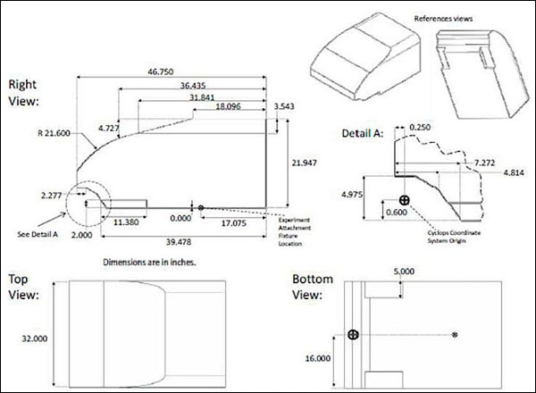
Diagram 1-2 CYCLOPS Deployment Volume

Trajectory Considerations
Make use of alternate minimum energy trajectories (e.g., ISEE3 example, bi-elliptic, weak stability boundary, libration point, etc.). The classic example to what length the use of alternate minimum energy trajectories can be taken is show in Diagram 1-3 ISEE 3 Orbital Trajectory.
We are currently calculating alternate minimum energy trajectories that would allow for a deep space orbital injection from an ISS deployment that would result in a return trajectory that would achieve lunar orbit within a permissible and tractable time frame for the Alpha CubeSat mission. A notional representation of such a trajectory is shown in Diagram 1-4 Alpha CubeSat Notional Orbital Trajectory.
Competition requirement is for 1 year endurance of flight operations. Therefore there is time enough to be able to use low-energy trajectories at the expense of flight time.
Furthermore, the small size and mass of the satellite by competition requirements limits the available mass and volume for a propulsion system and propellants. Design must use alternate minimum energy trajectories to reduce the propellant volume requirement and allow space and mass for on-board hardware. First-order calculations of required propellant mass fractions for conventional Hohmann and bi-elliptic trajectories required propellant mass fractions on the order of ~80-90% for a short duration high thrust propulsion system.

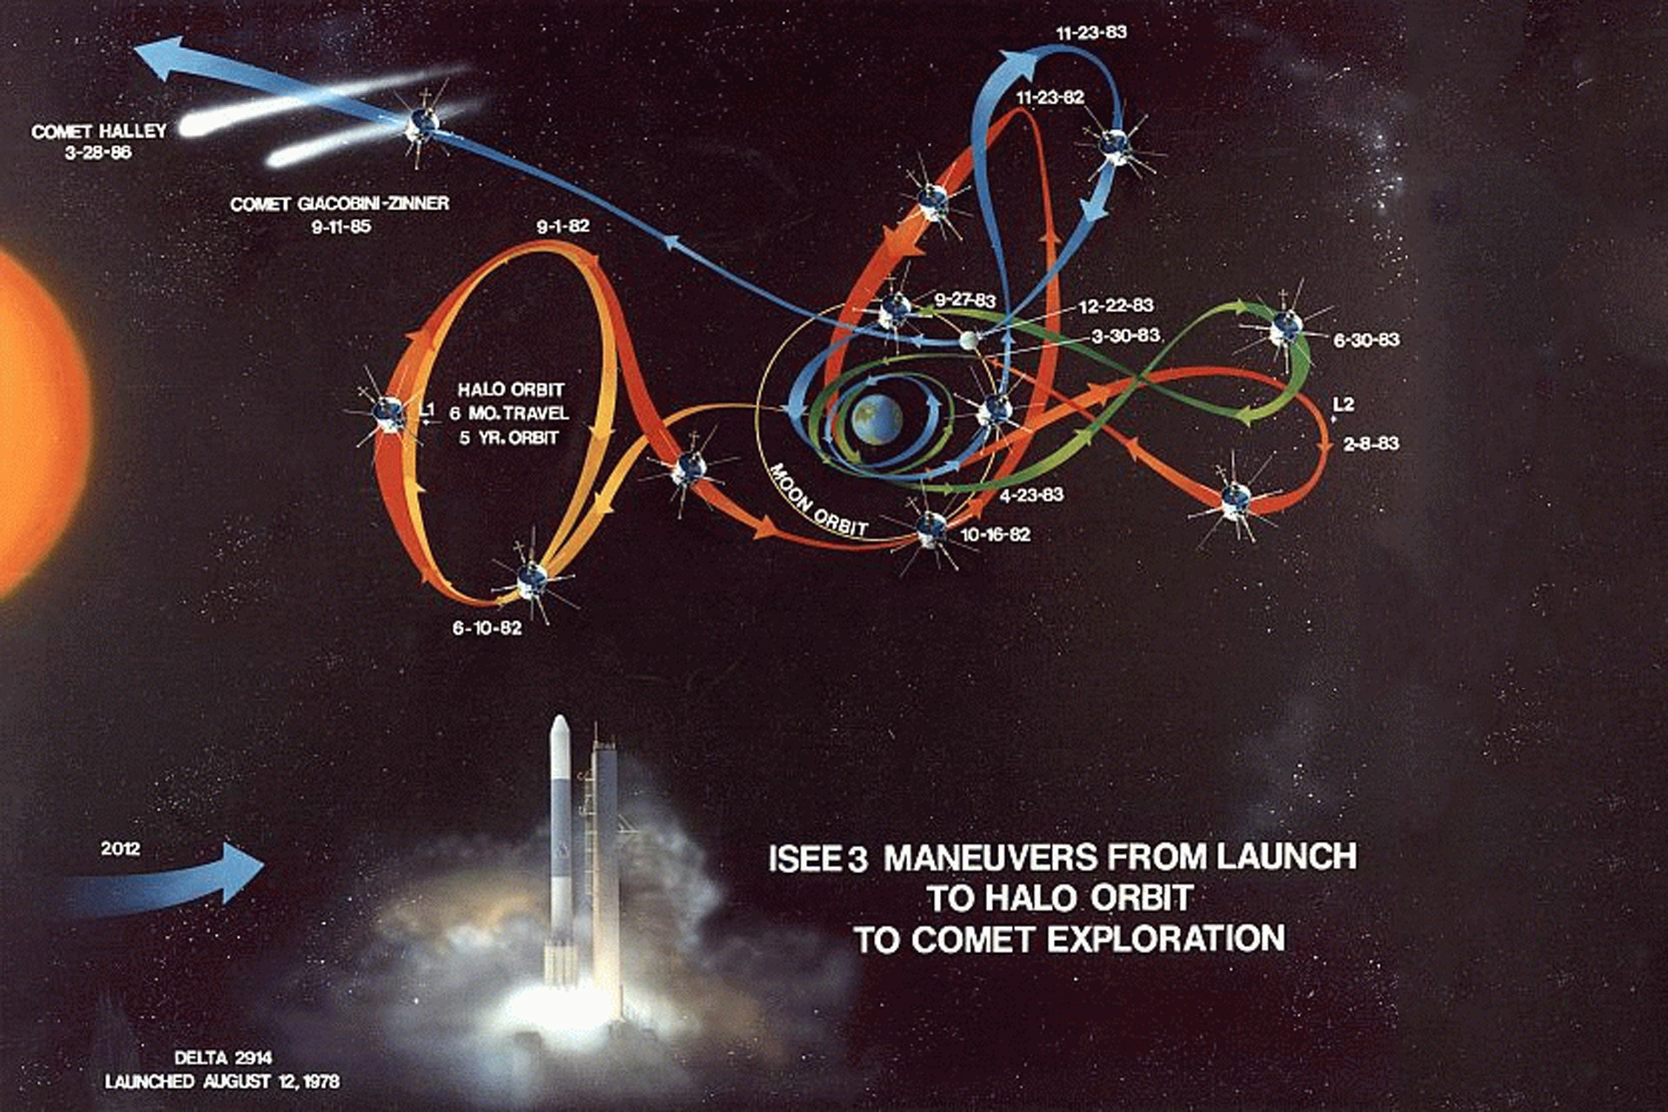
Diagram 1-3 ISEE 3 Orbital Trajectory

Attitude Control System Considerations
The Alpha CubeSat Attitude Control System is likely to consist of four main components.
- Magnetic Torquers to facilitate alignment after deployment in Low Earth Orbit before the trajectory insertion burn. Magnetic Torquers may also be of some use in Lunar Orbit and/or to assist in some configuration issues.
- Ion Thrusters to provide a low thrust long duration propulsion option.
- Cold Gas (CO₂) Thrusters will be incorporated if the mass budget permits.
- 3 axis Reaction Wheels will be defined as an option for incorporation if the mass budget permits.
- Sun sensors will be incorporated as explicit elements and/or as calculable derived data from other subsystems.

The notional placement of these subsystem components is shown in Diagram 1-5 Alpha CubeSat Conceptual Design Volumetric Model V 1-1.

The number and placement of the Magnetic Torquers will depend on their mass and their calculated utility during each phase of the mission.
The possibility exists that alternate fuels when combined with a sufficient amount of power could improve performance if not obviate the need for one or more of the Attitude Control System elements.

Communication Considerations
Ka Band is the frequency baseline for communications. The notional available layout real estate for transmitting and receiving antenna elements is shown in Diagram 1-5 Alpha CubeSat Conceptual Design Volumetric Model V 1-1.
Resources permitting, or if mission requirements dictate, a non-standard frequency allocation request and/or experimental license request will be filed to allow use of a higher regulated or unregulated frequency band.
The Alpha CubeSat link budget is still under development. However, based on the combination of baselined frequency choice, the baselined use of the DSN, and the assumption that the electrical power system can through a combination of solar cells and batteries provide sufficient power to drive the transmitter through a well pointed antenna, the ability to receive some amount of data is a virtual certainty. As to how often data transmission can be done, what the achievable throughput will be, and the longevity of the system – these and all the other Cube Quest Challenge metrics be addressed as part of the Alpha CubeSat design iteration and recursion.
Communications system broadcast power and pattern and radio hardware and antenna systems must be designed and/or selected to sufficiently meet the Cube Quest challenge requirement to communicate over a distance of 4 million km from Earth. It must also enable a sufficient burst data and net data transmission rate and volume to meet competition requirements.

Articulated Subsystem Considerations
The combined folded solar arrays/reflector, receiving/transmitting antenna, and potential solar sail/rudder will be released after the successful completion of the Deep Space/Cis-Lunar orbital injection burn. The notional deployment volumes are shown in Diagram 1-5 Alpha CubeSat Conceptual Design Volumetric Model V 1-1.
The release will be by commanded burn wire or equivalent, freeing the bottom portion of the two tandem 1.5U x 3U sections with the hinge point being opposite edges of the top of the Alpha CubeSat. The solar arrays/reflector/rectenna with then unfurl based on release of captive spring tensioners.
Completely unfurled the Solar Arrays/Rectenna will lock into place allowing the deployed canopy to be optimized for use in some combination of ways. It is anticipated that the size and shape of the canopy can and will be optimized to concentrate sunlight on to solar cells, serve as a transmitting antenna, serve as a receiving antenna, act as a solar sail with some modest but measurable efficacy, as well as acting as a Ka/W band rectenna for pre or post non-contest related tests.
For improved reliability of these systems, the design will be biased to towards mechanical simplicity and the reduction and/or elimination of moving parts to reduce system wear and increase reliability. Such will be done by the use of spring-force deployment systems released by being cut free by burn or muscle wire.
At this time, we do not anticipate the use of complex electromechanical systems such as servos.

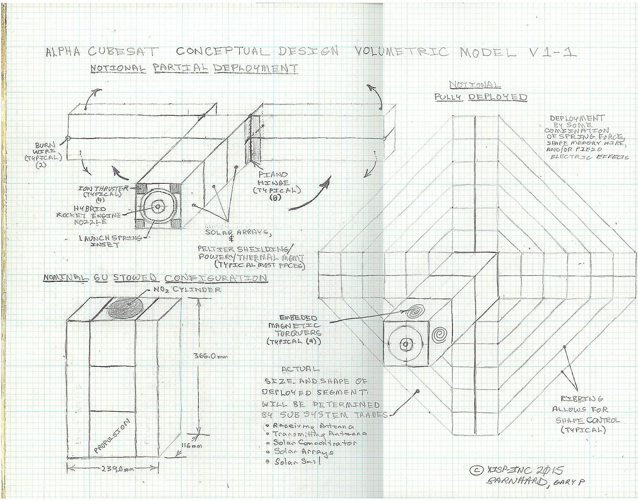
Diagram 1-5 Alpha CubeSat Conceptual Design Volumetric Model V1-1

Electrical Considerations
The notional layout real estate for Solar Cells and Peltier surfaces are shown in Diagram 1-5 Alpha CubeSat Conceptual Design Volumetric Model V 1-1.
The use of hybrid band gapped solar cells with solar concentrators is baselined.
The use of unified bus backplane(s) is baselined.
The use of integrated receiving antenna (rectenna) technology with direct or indirect solar array functionality is baselined.
Power requirements and use scheduling of all electrical systems for communications, guidance, navigation and control, propulsion and sensors will drive the sizing and type designation of the solar power system as well as power storage.
Power management will need to be planned and controlled on the vehicle to optimize the power system for operations and size and mass on the limited available size and mass of the Alpha CubeSat system.

Navigation Concepts
It is anticipated that Alpha CubeSat will obtain a navigation fix using best the available tools (e.g., geospatial positioning constellations, etc.) while in LEO, and by the DSN while on the competition trajectory for the Deep Space Derby and the Lunar Derby.

The provision of geospatial positioning constellation access will be negotiated services with the respective constellation managers in coordination with NASA, our teammates, and sponsors.

Propulsion Considerations
The notional placement of the propulsion system components is shown in Diagram 1-5 Alpha CubeSat Conceptual Design Volumetric Model V 1-1.
Alpha CubeSat intends to use some combination of Ion Thrusters, Cold Gas Thrusters, and a solar sail/rudder to provide Low Thrust Long Duration Propulsion capabilities.
The use of a long duration and/or repetitive use low thrust propulsion system is baselined. Some combination of ion thrusters, solar sail, and cold gas thrusters will be incorporated into the Alpha CubeSat design scaled to meet the mission requirements.
In addition, the use of a short duration high thrust propulsion system is baselined for the initial orbital injection maneuver. An in-line hybrid Nitrous Oxide and Acrylic/Paraffin propulsion system is the leading alternative at this time.
The possibility exists that alternate fuels when combined with a sufficient amount of power could improve performance of one or more of the selected propulsion components.
Q13: What is the review/waiver process that will be required for propellant or blow-down tanks that meet the criteria of being pressure vessels (either through pressure, internal energy, or pressure + hazardous materials)?
A13: Depending on the criteria that caused the item to be deemed pressure vessel (energy storage/pressure level/content toxicity) you will need to provide structural analysis and finally pressure testing data on the vessel. If the vessel is a Commercial-Off-The-Shelf (COTS) item the vendor certification data will probably be sufficient as long as you stay within the products design parameters. If the vessel is of a new design you’ll need to have several with some being tested to destruction through yield and burst tests. You also have to show a vessel leaks before rupture (doesn’t become a bomb). And you may have to add safety features into a pressure system (relief valves, burst discs, active monitoring, etc.) which is all dependent on what your system is and how you have it designed. You will have to present your plans to the PSRP for how you’re going to qualify a pressure vessel at Phase II. At Phase III you will have to present your data showing test conditions and results. Don’t forget, in many cases the “pressure” issue doesn’t stop w/the vessel but also continues to other components which must meet similar requirements.
The drive to use alternate minimum energy trajectories stems from the need to have a reasonably small propellant mass fraction onboard the satellite. Conventional trajectory solutions have been found to yield untractable solutions. Accordingly, there is need to further improve the mass fraction by choosing propulsion systems appropriate for low-energy trajectories and propellants that grant improved specific impulse, and reduced propellant volume. Furthermore, with the long-endurance mission profile, we need to select propulsion systems and propellants that are long-term storable and maintain high reliability over an extended lifetime.

Command & Control Concepts
The Alpha CubeSat will make use of an augmented set of the NASA ARC Mission Control technologies suite that will enable a near realtime state model of the system to be used to manage all command, telemetry, and data streams.
Resources from robotics control law and open-source Guidance, Navigation and Control (GNC) methods will be employed to develop GNC systems, hardware for a flight computer and control software, for Alpha CubeSat.

Thermal Considerations
The Alpha CubeSat will spend most of its life after leaving LEO in full sun. However, given the distances involved and the limited amount of on-board power consumed during most operational states (though not all) measures must be provided to both generate and dissipate heat.
Likely scenarios include the need to turn the transmitter on often enough to help keep the satellite warm and to turn it off/throttle it when it is in danger of overheating.
Passive systems such as shading, coloring and active deployment of shades and louvers are also likely systems needed. Where the passive systems do not suffice, active thermoelectric systems will be deployed for mechanical simplicity.
It is anticipated that the management of thermal cycling may prove to be a defining factor in the longevity of the system.

Conceptual Considerations
The Alpha CubeSat design will implement a combination of selective Peltier shielding/power generation/thermal management tiles, a protected core operating system kernel, Error Correcting Code (ECC) memory, a self-throttling thermally managed multi-core processor, and a heartbeat reboot/recovery timer.
It is anticipated that the combination of the above measures should materially mitigate the impact of the anticipated radiation exposure allowing a higher performance processor to be flown, potentially a state-of-the-art multi-core mobile processor.
The Alpha CubeSat design will consider a full range of processor/single board computing options ranging from available RAD hardened units to the Intel Next Unit of Computing (NUC) Core i5 systems.

Conceptual Method of Disposal
The Alpha CubeSat Team understands and acknowledges the NASA Cube Quest Challenge Requirements that every possible effort needs to be made to prevent disturbance of lunar legacy sites and/or contamination of the Mars biosphere by either a malfunctioning or an end-of-life Cube Quest Challenge related flight article.
Depending on the available resources Alpha CubeSat will either be commanded to a lunar impact or if more appropriate a Deep Space non-returning trajectory.

PRELIMINARY FREQUENCY ALLOCATION DATA PACKAGE
The NASA Cube Quest Challenge Mission Concept Registration Data Package is required to address the preliminary frequency allocation data package. This is pursuant to Cube Quest Challenge Rule 5 and subsequent Rules which require development and submission of a Radio Frequency Authorization to assist with the licensing process. This requires the download and installation of the EL-CID software, and the use thereof to create a compliant license filing application.
Q8: What is a "Preliminary Frequency Allocation Package", as referred to in Rule 3?
A8: The “Preliminary Frequency Allocation Package” should include, as a minimum, the following information:
1) Planned frequency band(s) for satellite command and control, navigation, and high-speed telemetry
Ka Band, specific frequency selection will be driven by the available transmitters and frequency contention considerations if any.
2) Planned date(s) for filing for FCC ELA or STA license(s) (needed before transmitter operations)
As soon as an acceptable transmitter package can be found and a satisfactory and sufficient answer to any frequency contention considerations.is arrived at, the filing will be made.
3) Planned number and location(s) of ground/space stations
- DSN Earth Station Goldstone (Primary)
- DSN Earth Station Madrid (Primary)
- DSN Earth Station Canberra (Primary)
- - - - - - - - - - - - - - - - - - - - - - - -
- NEN Earth Station Whitesands
- Satellite International Space Station
- Satellite TDRSS Constellation
- Satellite Alpha CubeSat
- - - - - - - - - - - - - - - - - - - - - - - -
- Alternate Earth Stations (TBD)
- Amateur Radio Earth Stations (TBD)
All contest compliant transmissions will be through the NASA DSN.
4) Name of owner/operator of planned ground station(s)
NASA Deep Space Network (Primary)
Alternate Ground/Space Stations will be considered based on a case by case basis.
5) Planned transmitter power, modulation method, and coding (if known at this time)
Not known at this time.
6) Planned operational scenarios (overview and summary of command and control concepts, number of transmissions per day/week, etc.)
Not known at this time.

EL-CID Status
Team Alpha CubeSat has downloaded and installed the EL-CID software and initiated the development of a preliminary Frequency Allocation Data Package.
We have identified the following potential interacting nodes:
- DSN Earth Station Goldstone
- DSN Earth Station Madrid
- DSN Earth Station Canberra
- NEN Earth Station Whitesands
- Satellite International Space Station
- Satellite TDRSS Constellation
- Satellite Alpha CubeSat
- Alternate Earth Stations (TBD)
- Amateur Radio Earth Stations (TBD)

